The project was done by Haseeb Balal (hhb10) and Muffadal Hussain (mmh240). The first part which was stop and wait was probably the easiest as not a lot was going on and it was a simple implementation with the sender sending a packet and the receiver receiving it one by one. The second part was probably the hardest as a lot of errors when connecting the sender and the receiver. The third one was not as hard because the second one had been done before doing selective repeated. It took my group partner and I quite a while to finish the project and hardcoding was done in order to complete the three tasks.

The version of python we used was python3, so when running it use that version. For stop and wait the sender will send a word and the receiver will receive it. In go back n the sender must enter a word and it will be sent 5 times to the receiver who will acknowledge it and will proceed with the go back n process based on the packet dropped and how many packets were acknowledged the program will ask the sender to enter another word to send to the receiver in order to have 10 in total. Selective repeat also will run similar to go back n as it will ask the user to send a word to the receiver, which will send it 5 times twice. The output will obviously be different since selective repeat prints out the dropped ack and packet. The project folder will contain other files as pycharm does that when creating a project but folders have been made with the appropriate sender and receiver files.

One note to make is that the Ack in the print statements is the index of the acknowledgement of how far it was sent until it was dropped. So if it says Ack 3 that means it sen until index 3 and stopped receiving.

Stop and wait sender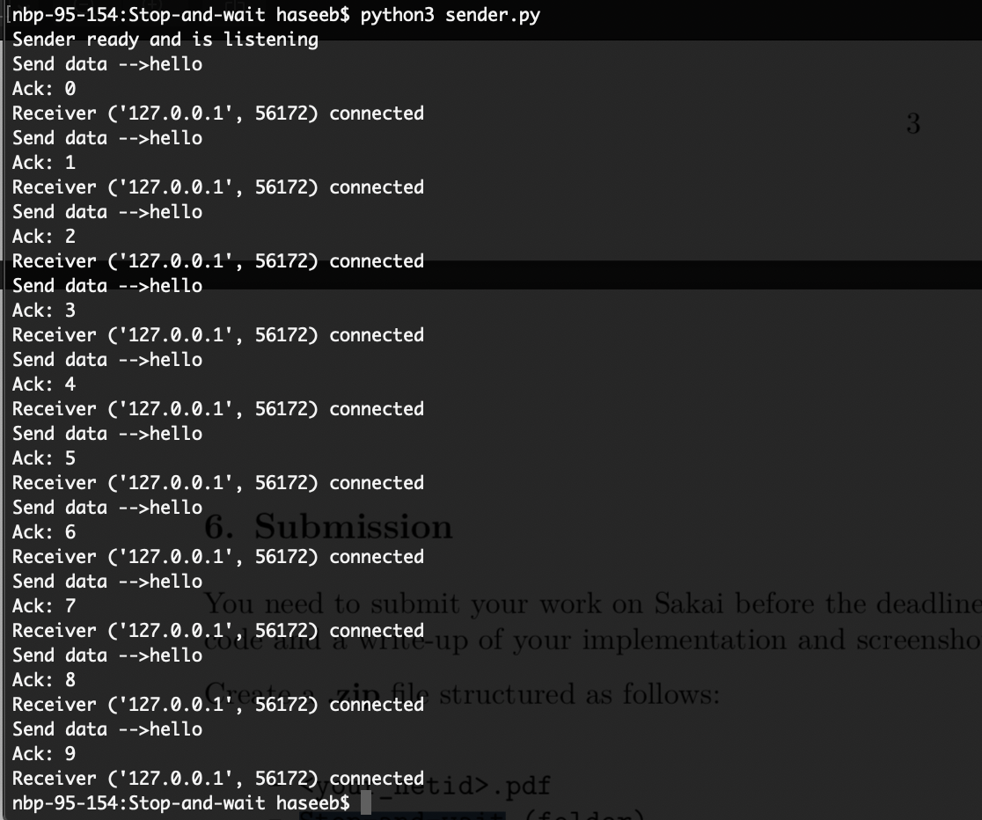

Stop and wait receiver

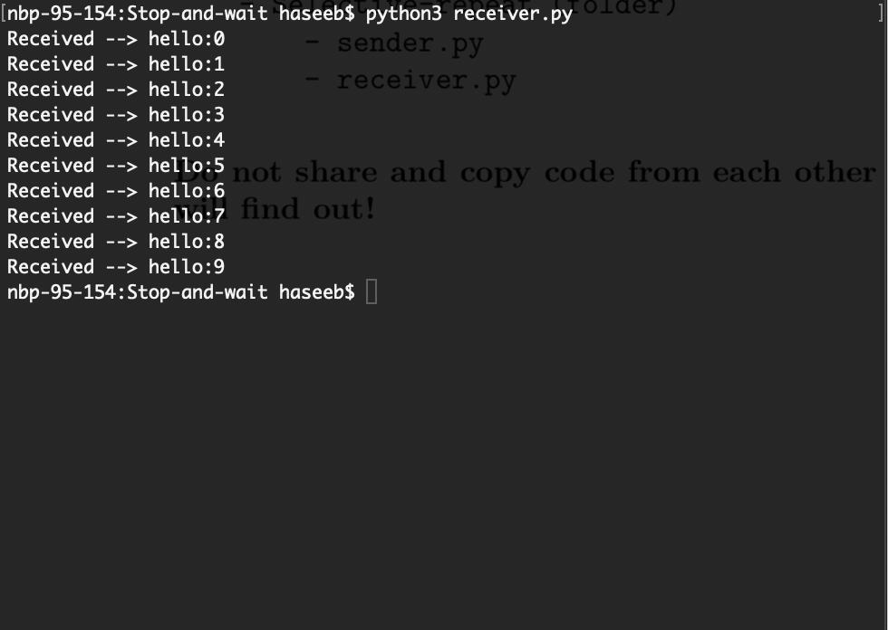

Go back n sender

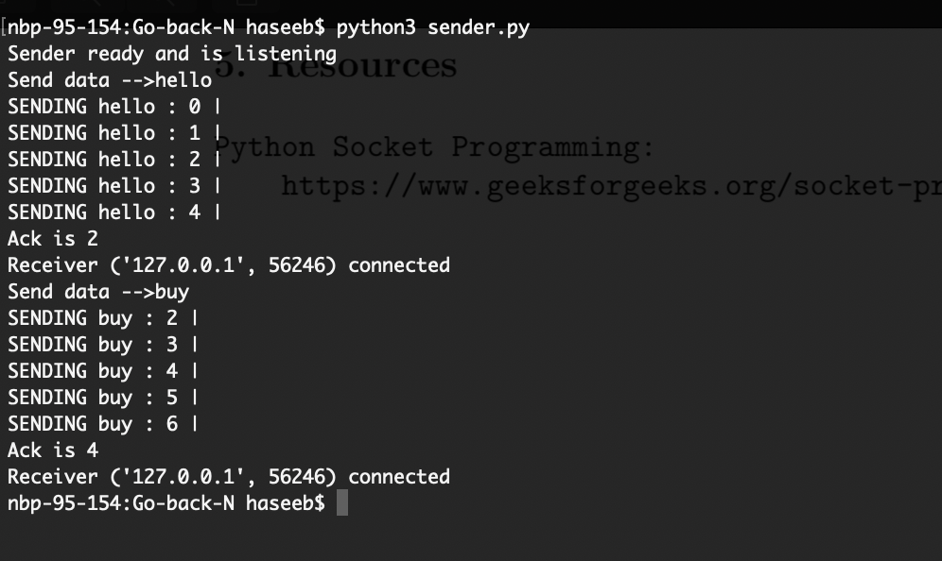

Go n back receiver

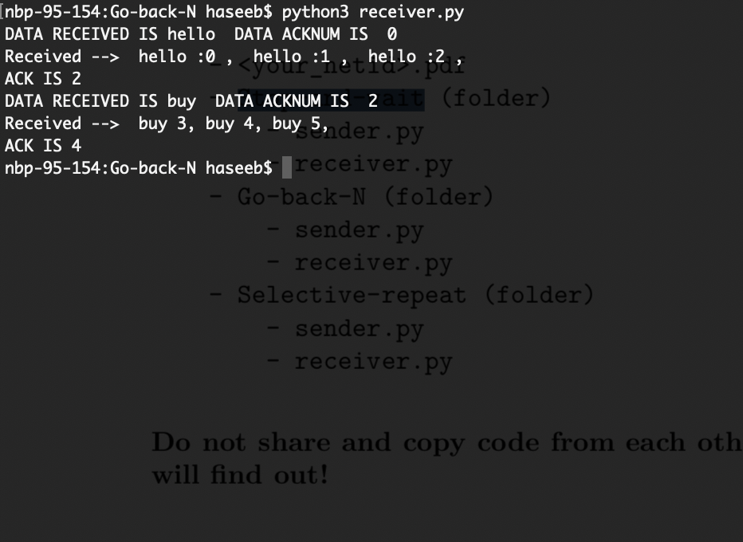

Selective repeat sender

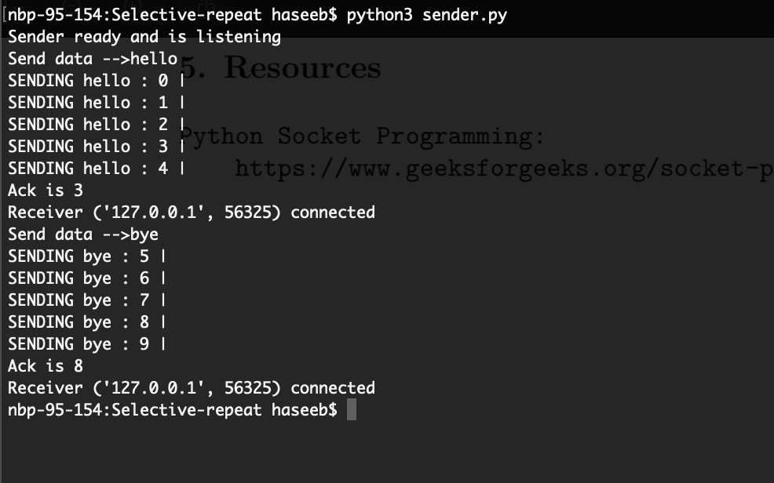

Selective repeat receiver

